LOGBOOK
MОRNING OF THE SPAСE ERА

6—7 LEVELS

Block А

SPACESHIP

DATE OF THE FLIGHT

Commander

Crewman 1

Crewman 2

Crewman 3

Crewman 4

Crewman 5

Crewman 6

The first flights to space. 1957–1960
Block B

- Match the event and the date.
The flight of the first artificial satellite

August 1960

The flight of the dog Laika

October 1957
The flight of the dogs Belka and Strelka

November 1957

- Look at the replica of the first artificial satellite of the Earth. Count how many antennas it had. You can draw the satellite.

The first artificial satellite had antennas.

The first manned flight
Block C

- Correct the sentences.

The first manned flight to space was made in 1960.

The second cosmonaut of the world is Jury Gagarin.

- Find out the exact time of Gagarin’s start. You have to imagine the clock in the mirror.

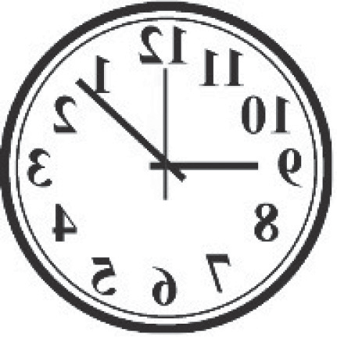
The flight started

:

The first walk in outer space
Block D

- Tick what A. Leonov could use in his flight.

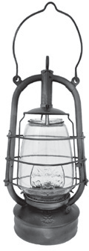
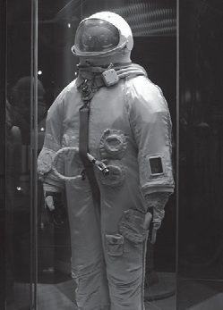
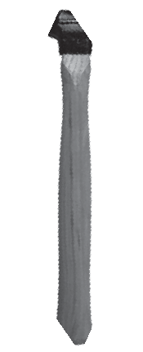
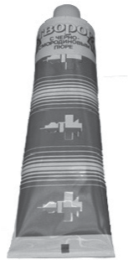

- Behind the airlock there is a showcase. Find out

- the name of the spaceship and the airlock

- the surname of the commander of the spaceship

The first probes to the Moon
Block E

- Put the planets in the right order beginning from the Sun (write the number of the planet).

Neptune Venus Uranus Mars Saturn Mercury Jupiter Earth

- Choose the right answer.

The Moon is .

  - a star b) a satellite
c) a planet d) a comet

The nearest star to the Earth is .
a) the Moon b) The Sun
c) Polar Star d) Mars

For notes
6

For notes
7

Разработано для музейного урока: И.Ю. Головкина

8

